**Object Types:**

1. Commit
   1. Comment
   2. List of files
   3. Pointer to a tree
   4. Username
2. Tree
   1. Pointer to Filenames
   2. Other trees
   3. Content
3. Blob
   1. The actual data

**Tag:** Specific version of the branch that is committed at a point in time

**Branch:** Version of the release, that all the development efforts are going on

Pointer to the latest commits.

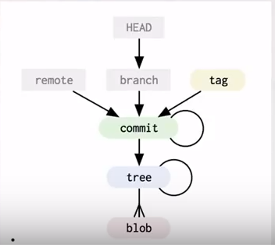

SHA1:

1. Hashing algorithm that gives a 40-char unique key for a file
2. This unique key can be used to avoid duplication
3. Same file with a different name can have the same hash and point to the same file